# **Configure HA Proxy Server:**

**Launch 3 ec2 instances name as Server1, Server-2, HA-Proxy-Server.**

Server-1 Steps:

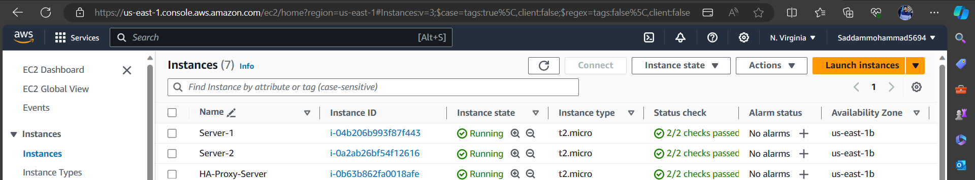

Run following command to Access the Server-1

* ssh -i your-key.pem ec2-user@Pubipaddress of Server-1 instance

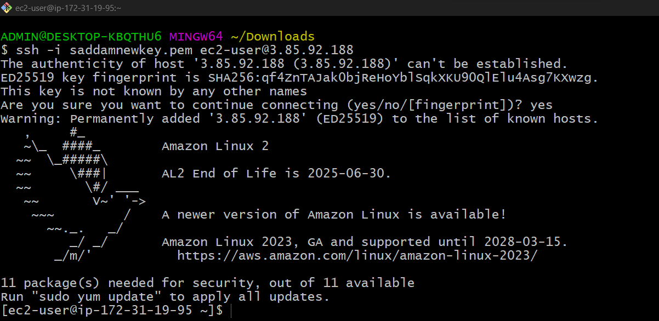

* sudo -i

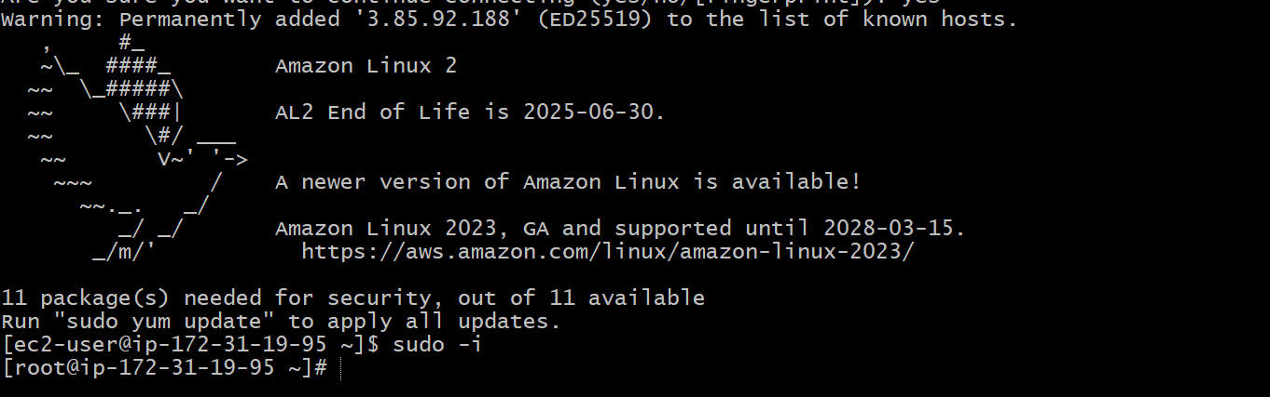

* yum update -y

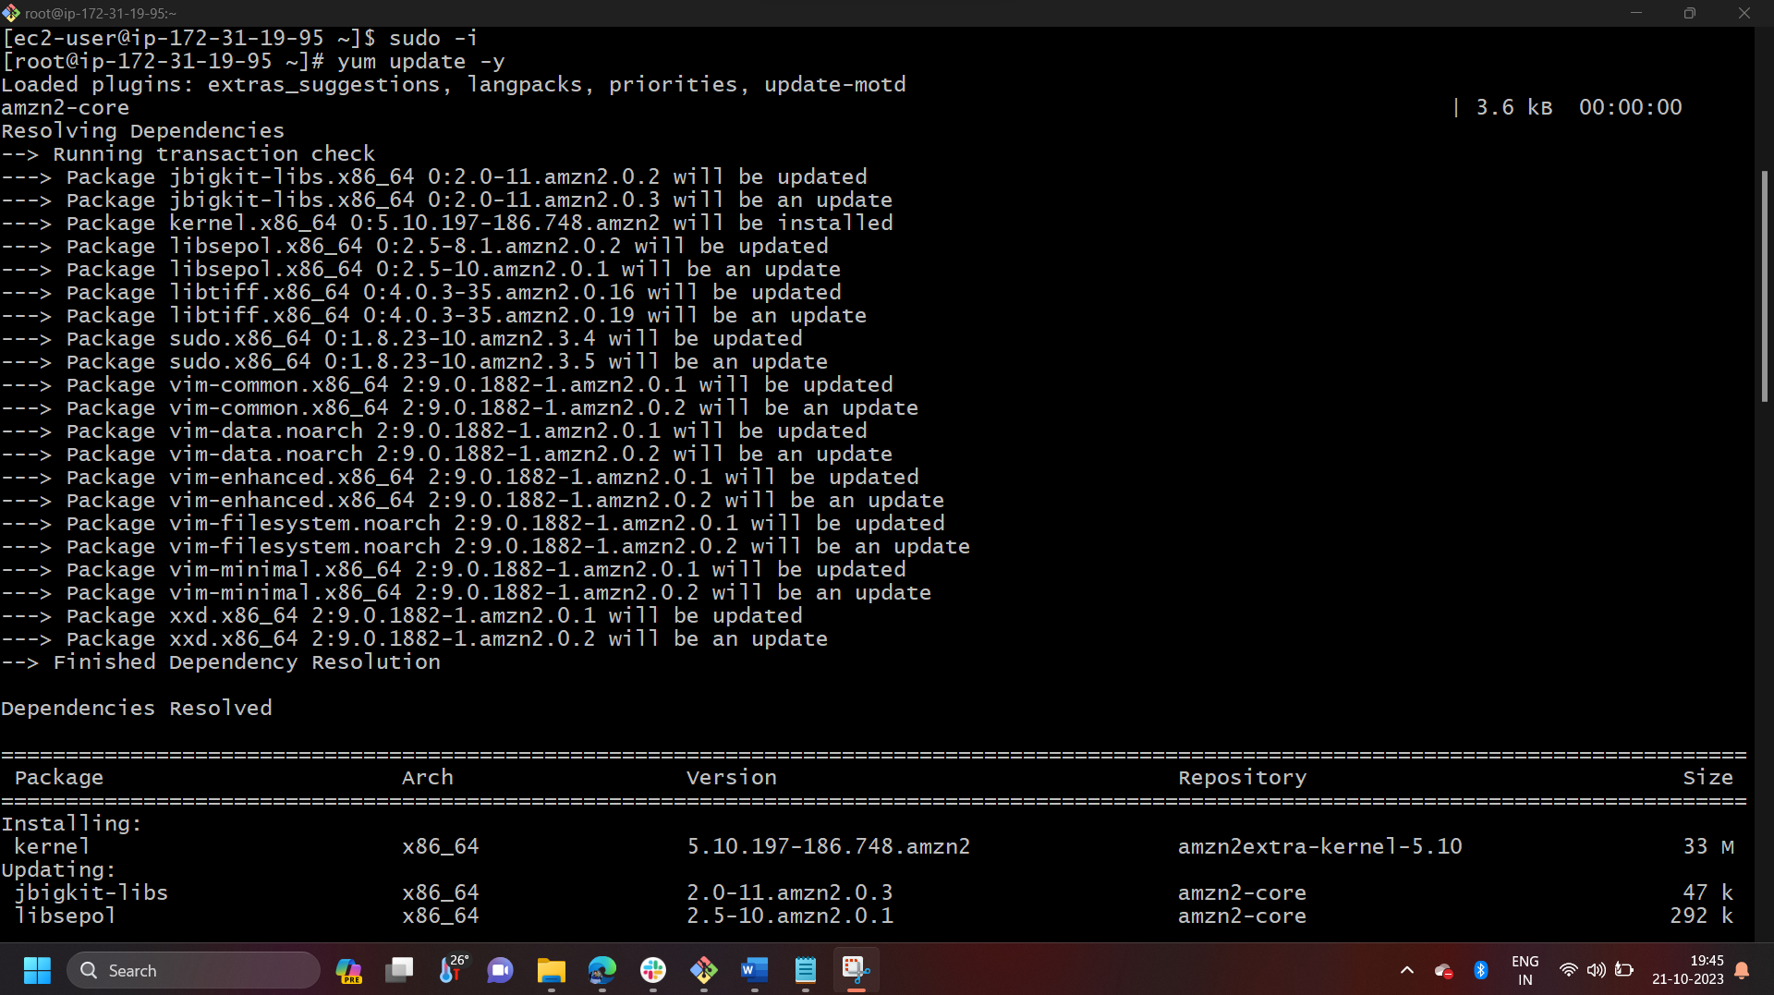 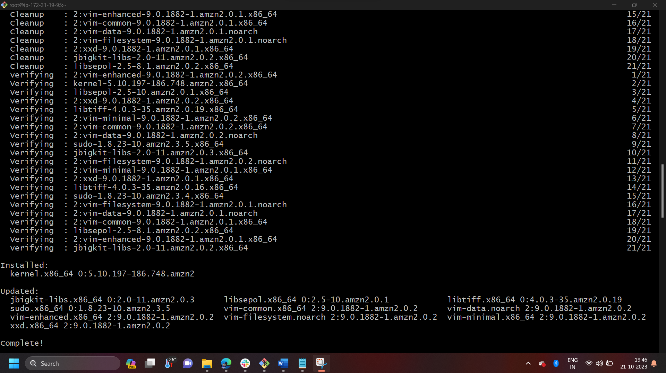

* Yum install httpd -y

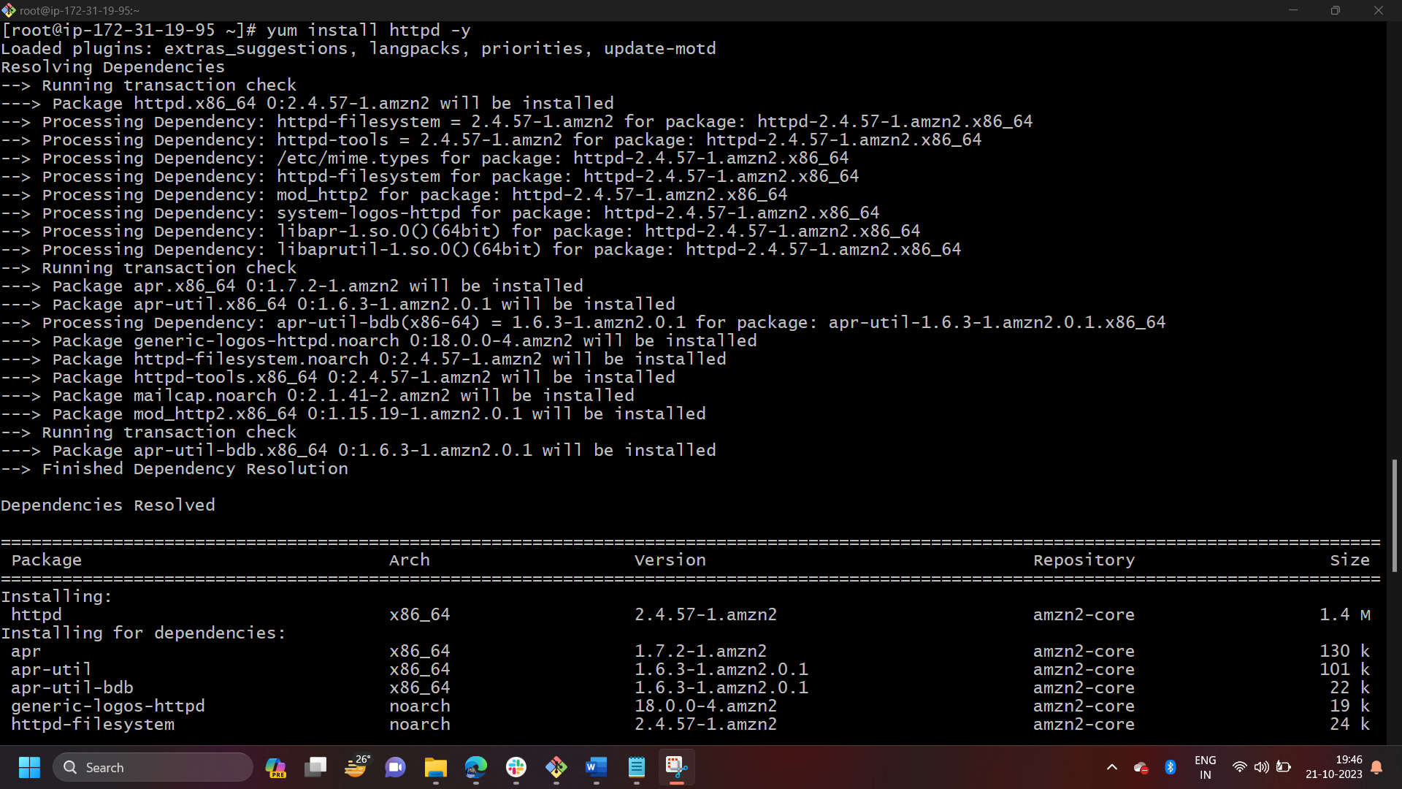 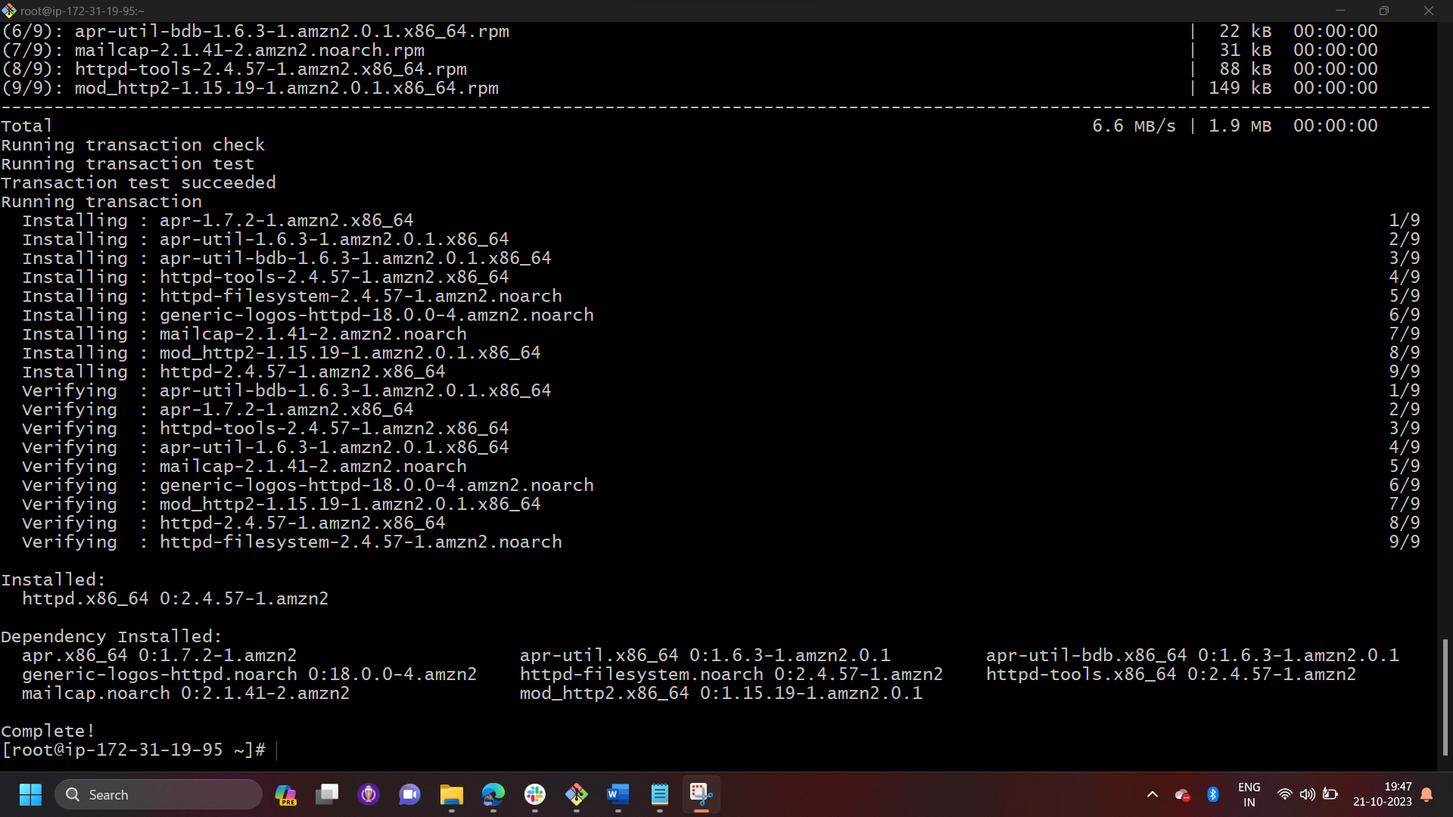

* Vi /etc/hosts
* Add HA-Proxy-Server Pubic IP Address





Run below command on Server-1  
ping load_balancer -c 4  
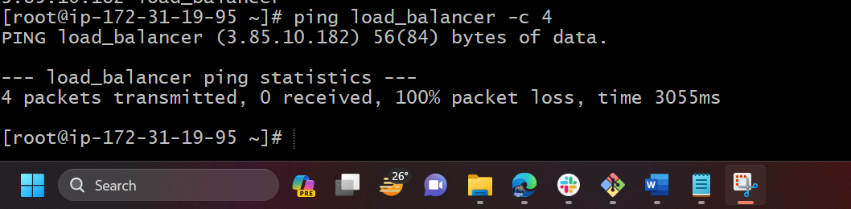

* systemctl start httpd
* systemctl status httpd

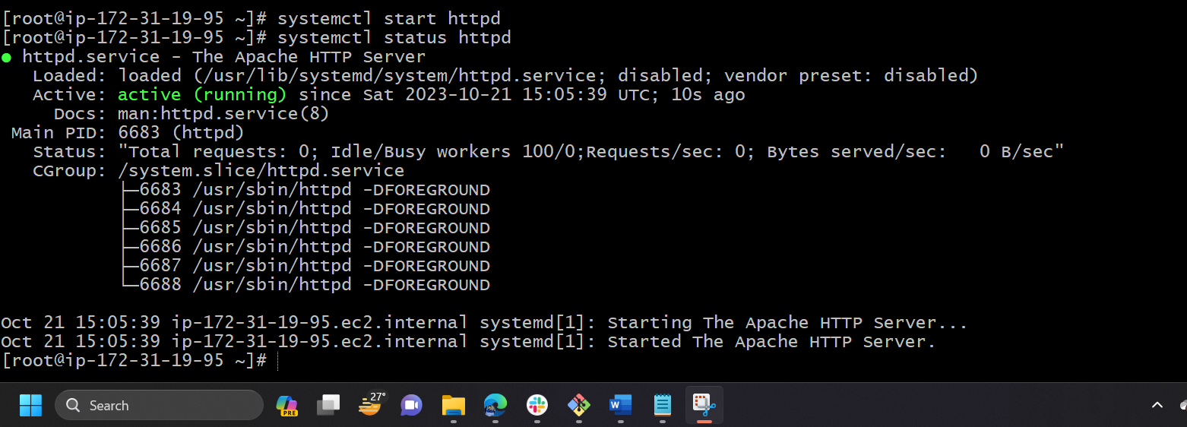

Browse with Server-1 Public IP address:80 it will work

Server-2 Steps:

Run following command to Access Server-2

* ssh -i your-key.pem ec2-user@Pubipaddress of Server-2 instance

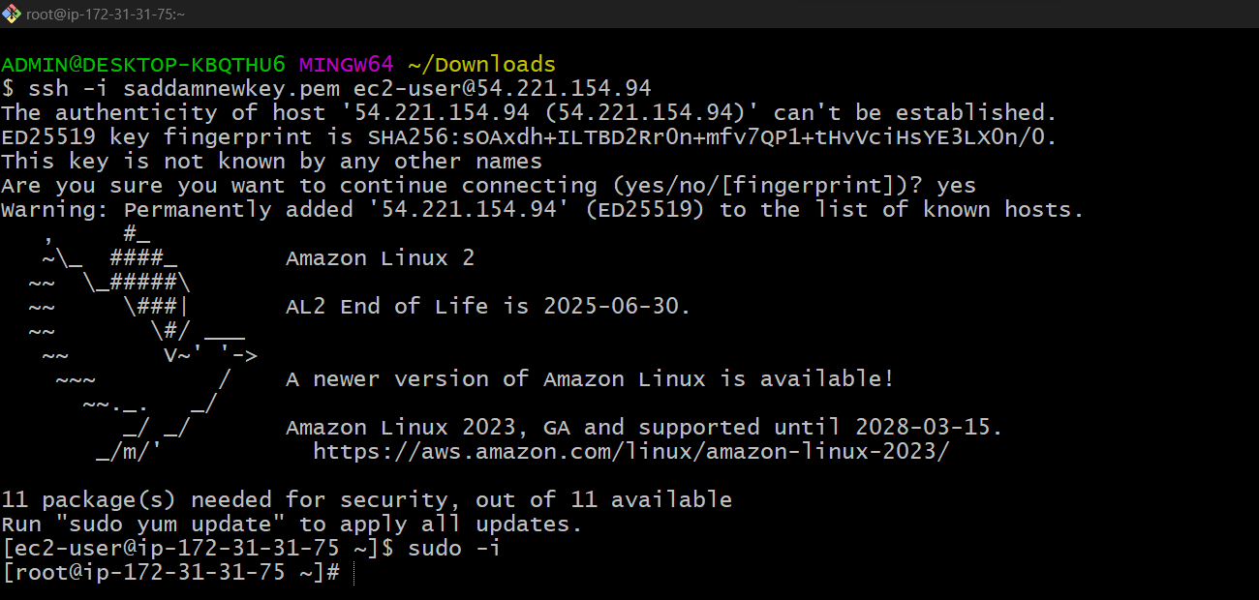

* sudo -i

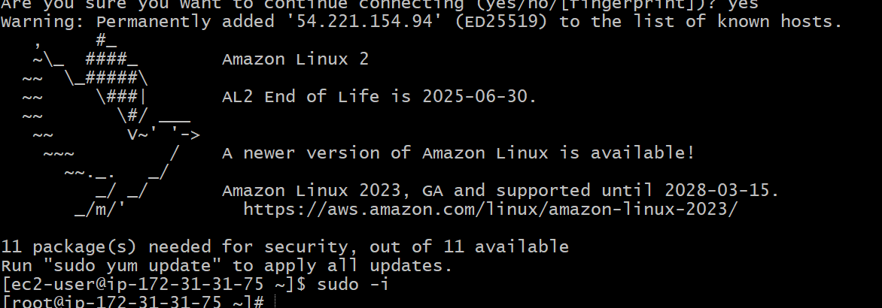

* yum update -y

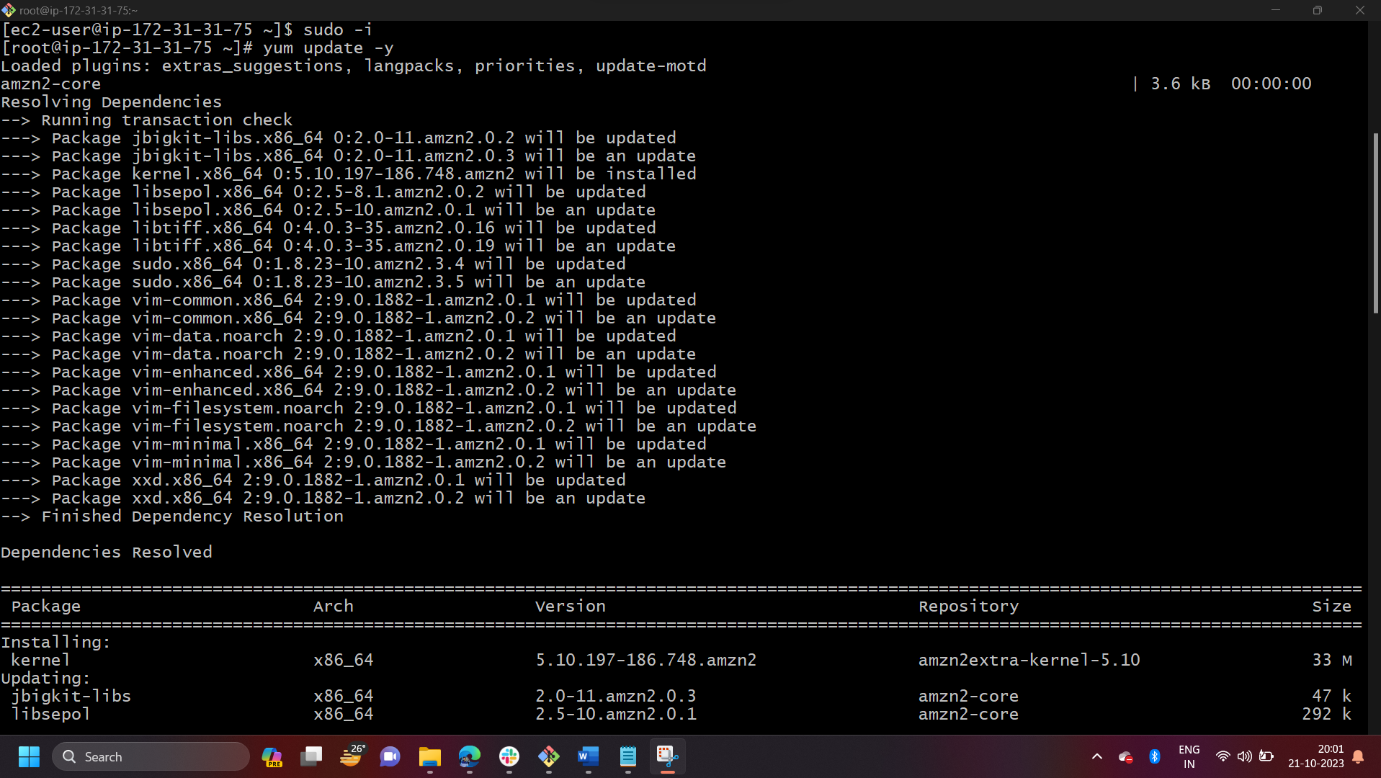 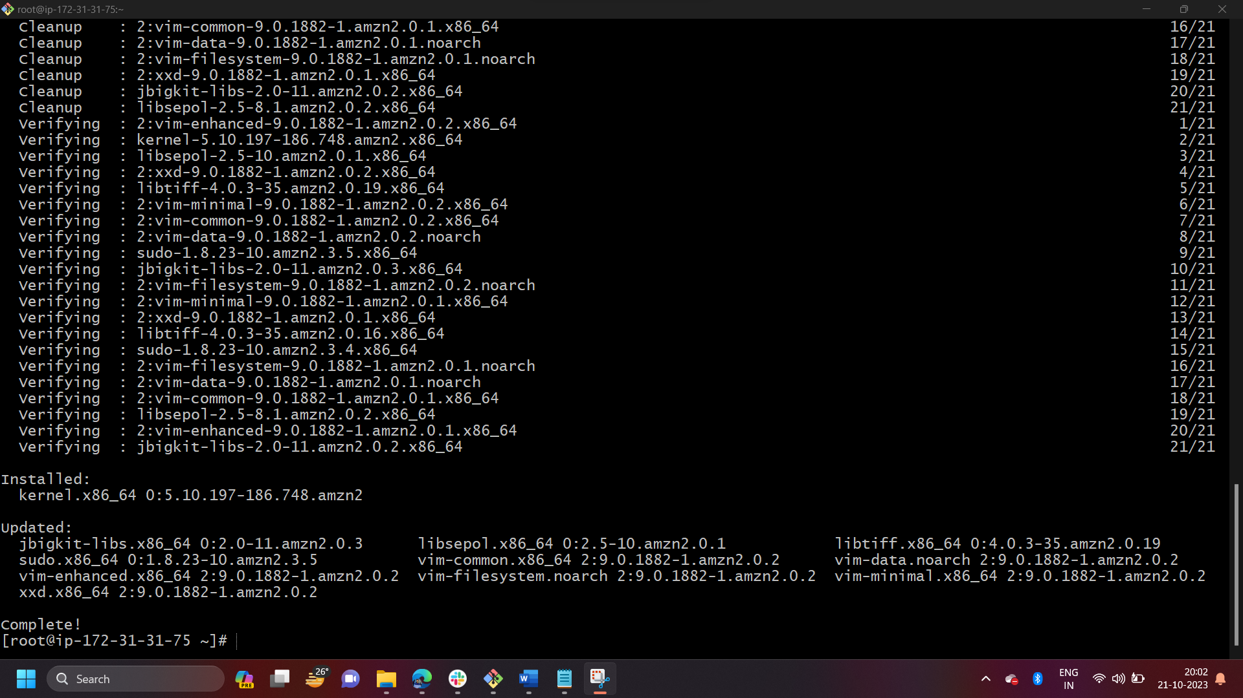

* yum install nginx -y
* sudo amazon-linux-extras install nginx1 -y

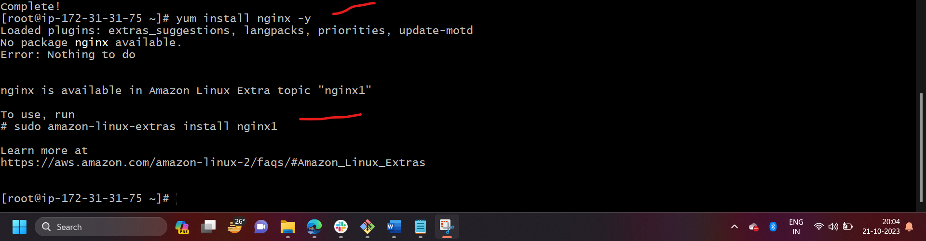 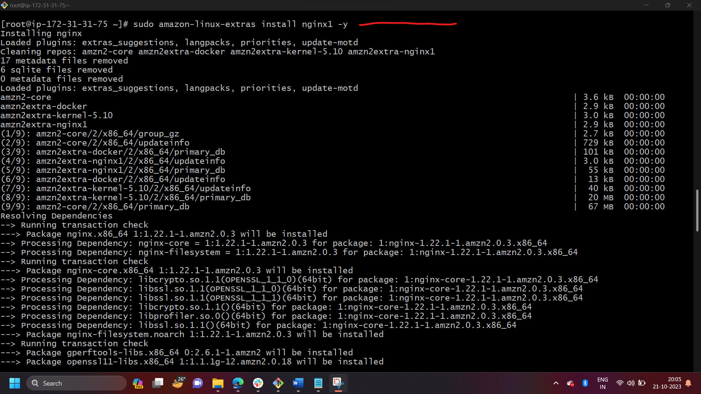

* vi /etc/hosts
* Add HA-Proxy-Server Pubic IP Address





Run below command on Server-2  
ping load_balancer -c 4

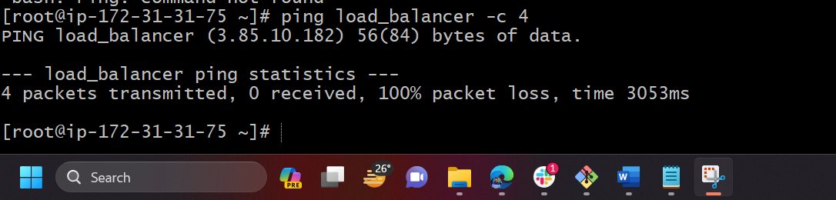

* systemctl start nginx
* systemctl status nginx

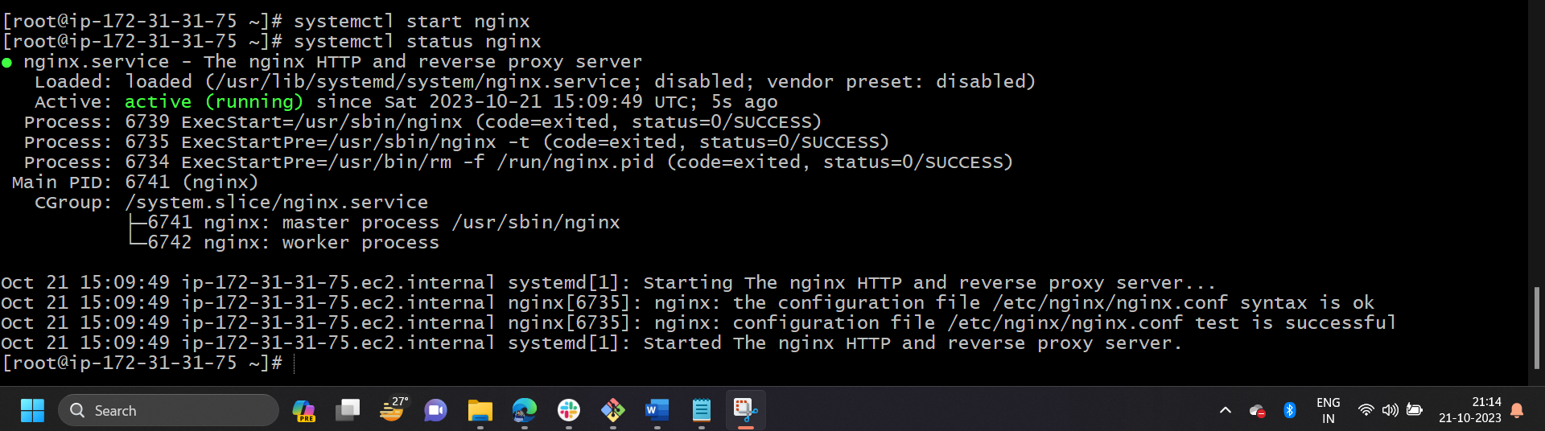

Browse with Server-2 Public IP address:80 it will work

HA-Proxy-Server Steps:

Run following command to Access HA-Proy-Server

* ssh -i your-key.pem ec2-user@Pubipaddress of HA-Proxy-Server instance

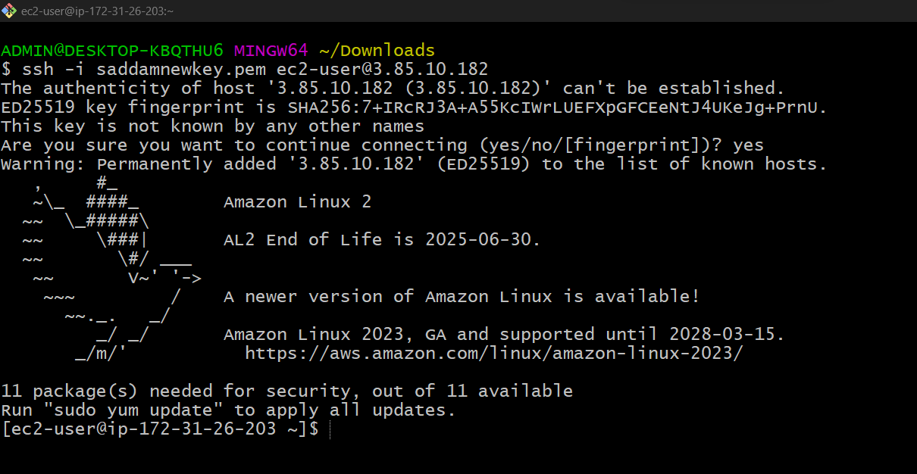

* sudo -i

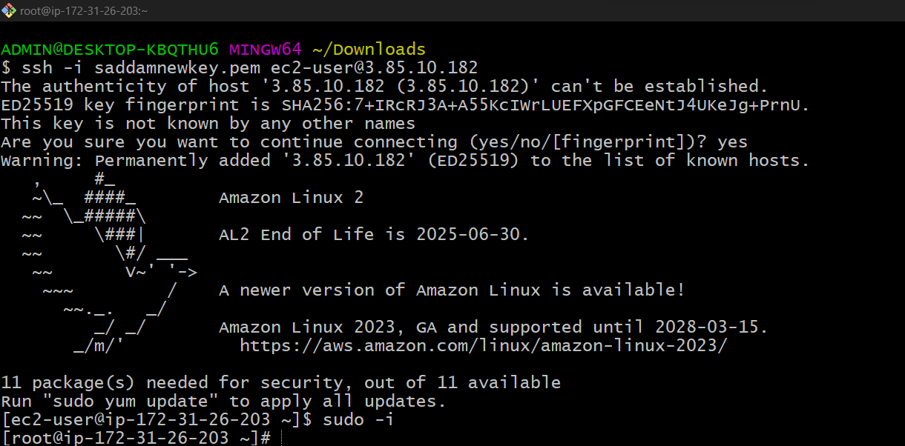

* yum update -y

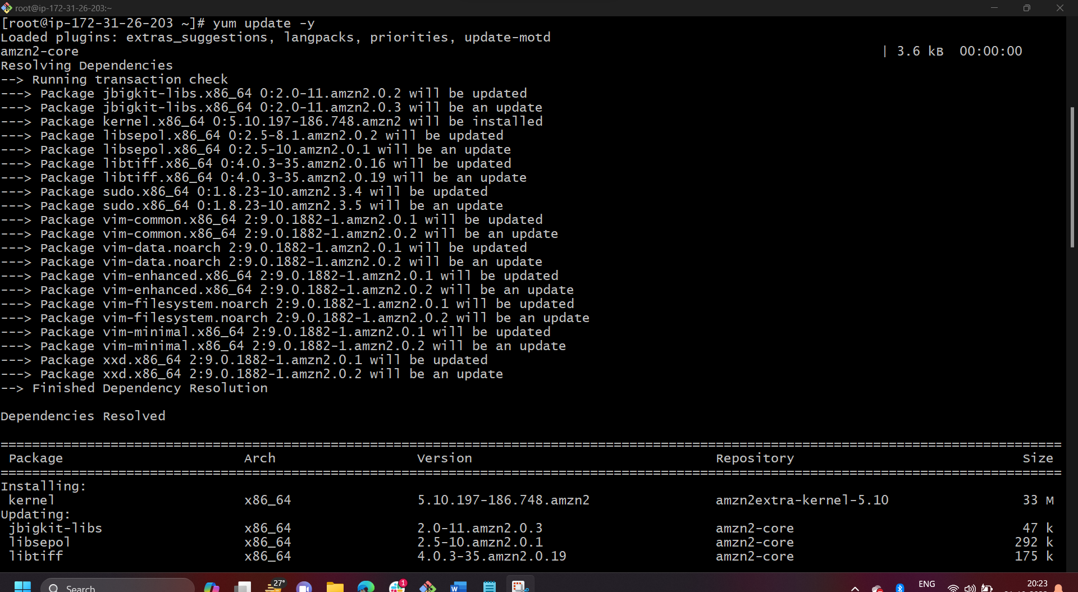

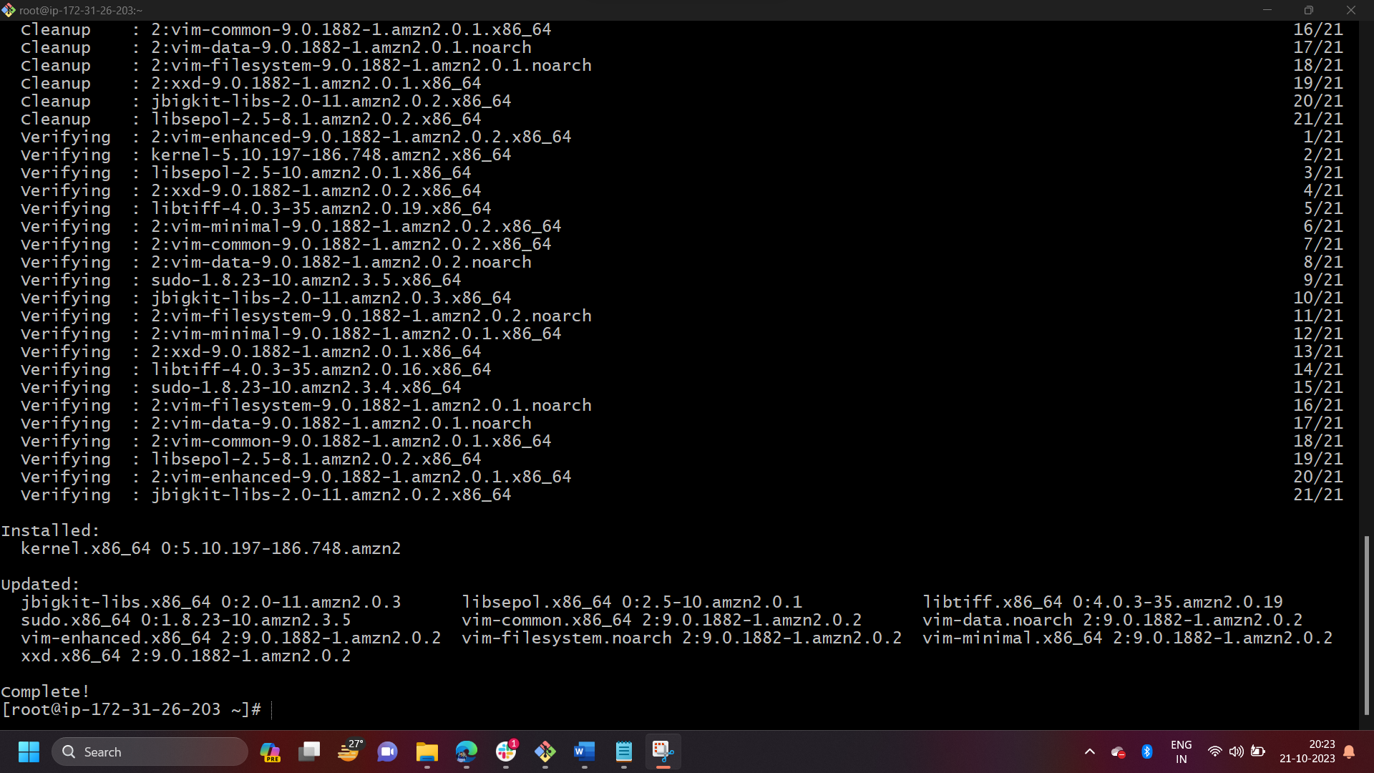

* yum install haproxy -y

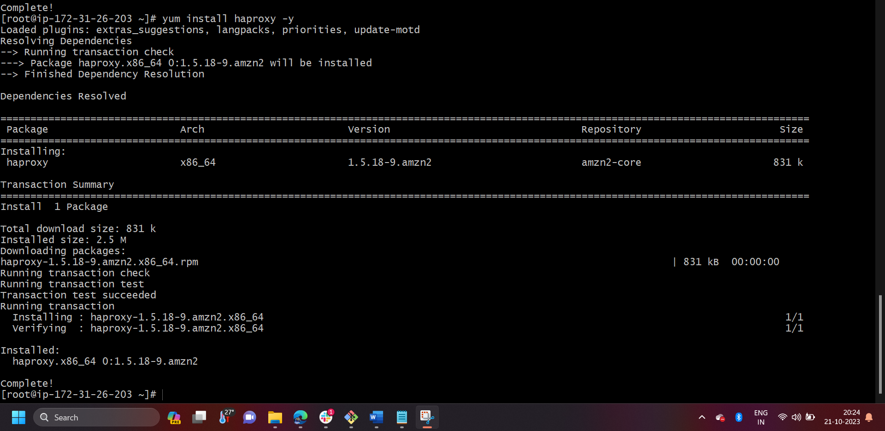

* vi /etc/hosts
* Add Server-1, Server-2 Public IP’s

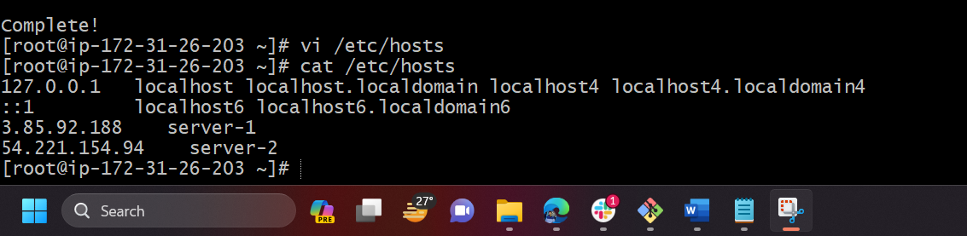



* vi /etc/haproxy/haproxy.cfg
* Add Server-1, Server-2 public IP’s

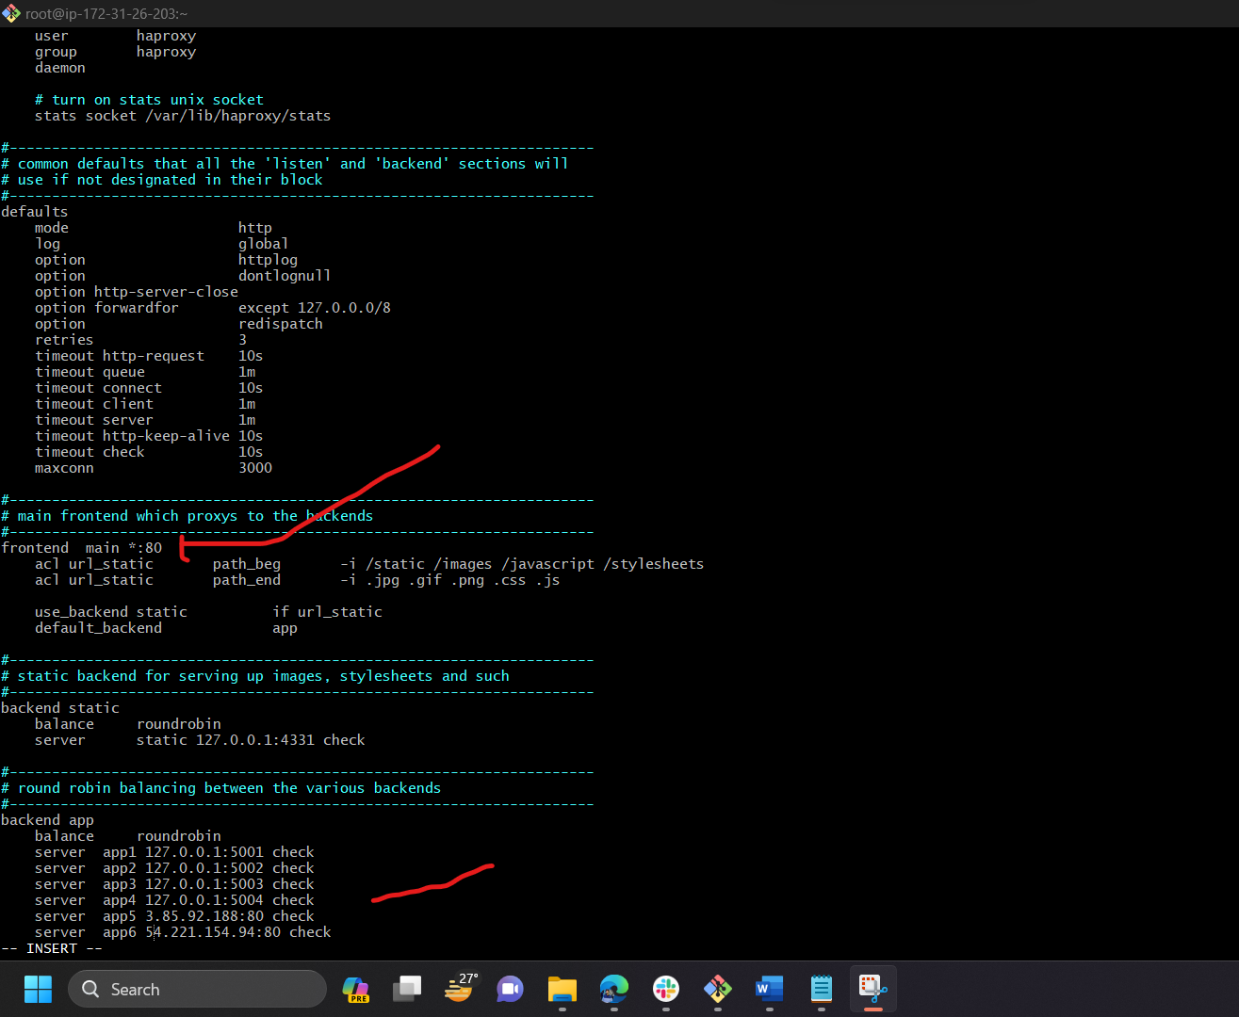

* systemctl enable haproxy
* systemctl start haproxy
* systemctl status haproxy

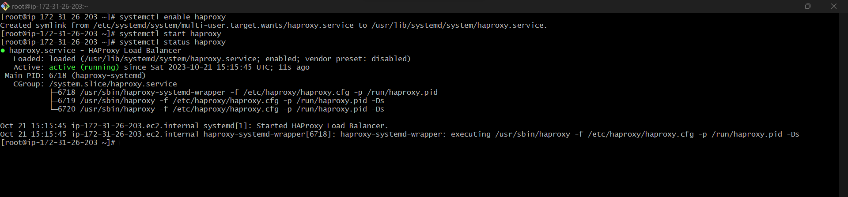

* now browse with HA-Proxy-Server PublicIP:80 it will distribute load to Server-1, Server-2